**Ansible – AWS Integration**

1. I am using here own AWS account, I already have user created into IAM section. I have activated **ec2_access_key** & **ec2_secret_key**.
2. I already have installed python in my machine. I installed python-pip and boto dependencies which are needed for Ansible AWS connection.

*sudo apt install python-pip*

*pip install boto boto3*

1. Created SSH key to connect ec2 instance after provisioning.

ssh-keygen -t rsa -b 4096 -f ~/.ssh/abhishek_aws

1. Created Ansible Directory Structure to place playbook and groupvars.

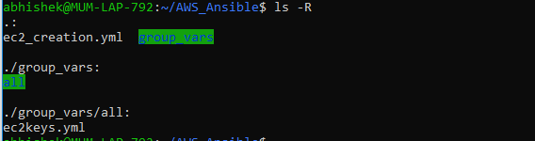

The ec2keys.yml is storingec2_access_key & ec2_secret_key in encrypted way using Ansible-vault.

**Ec2_creation.yml** is ec2 instance provision scripts.

1. Please have a look at the attached scripts

I have used **Ansible tags** into scripts which can be used to skip the particular from playbook.

1. **Ec2 Provision playbook brief explanation:**

* In playbook, we I using connection localto run script on Ansible server.
* In varssection, I have passed values for ec2 provision we can use separate INIfile to pass variable from outside playbook also.
* In the next section, I have used different task using Ansible aws module.
* ec2_instance_info
* ec2_key
* ec2_group
* ec2

Above module are used to gather information about aws resources and provisioning ec2 instance. Ec2 module is used to create instance use all passed parameter.

Command to run playbook:

*ansible-playbook ec2_creation.yml --ask-vault-pass*

*ansible-playbook ec2_creation.yml --ask-vault-pass --tags create_ec2*

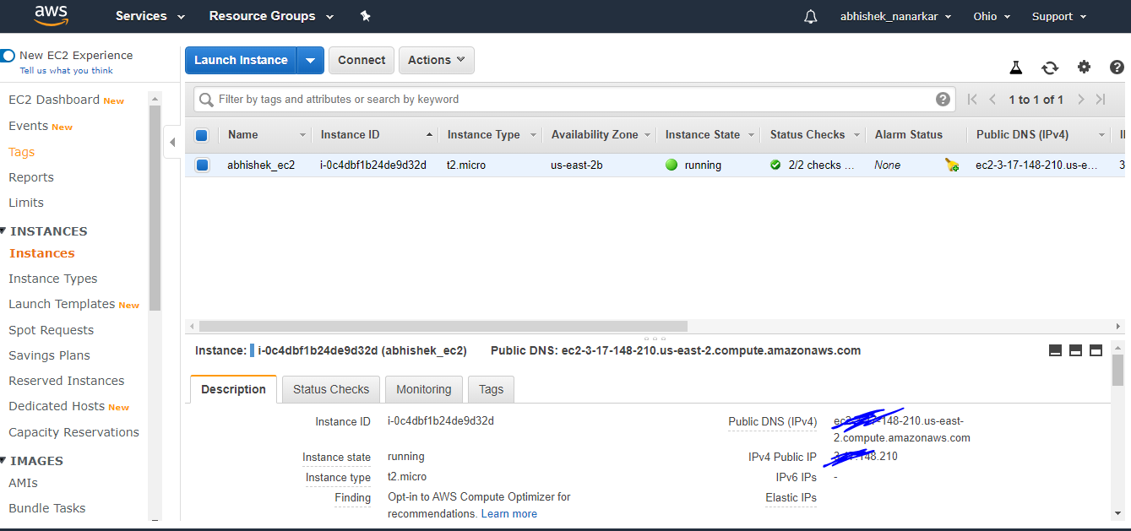

Connect ec2 instance :

*ssh -i ~/.ssh/my_aws <public dns name>*

**Ansible Dynamic Inventory Setup**

1. This is just as a bonus for this problem, I have configured dynamic inventory to install ELK on ec2 instance.
2. For Dynamic inventory, I have downloaded ec2.py and ec2.ini scripts, EC2 external inventory script and Ansible EC2 external inventory script settings.
3. I have set environment variable for

*export AWS_ACCESS_KEY_ID=<your_aws_access_key_id>*

*export  AWS_SECRET_ACCESS_KEY=<your_aws_secret_access_key>*

1. We need to set path for

*export* *EC2_INI_PATH=/home/abhishek/AWS_Inventory/ec2.ini*

*export ANSIBLE_INVENTORY=/home/abhishek/AWS_Inventory/ec2.py*

make ec2.py script executable.

*chmod +x  /home/abhishek/AWS_Inventory/ec2.py*

1. Once above setup done just need to run ec2.py script it wil fetch info about all the AWS resources which we configured inside ec2.ini

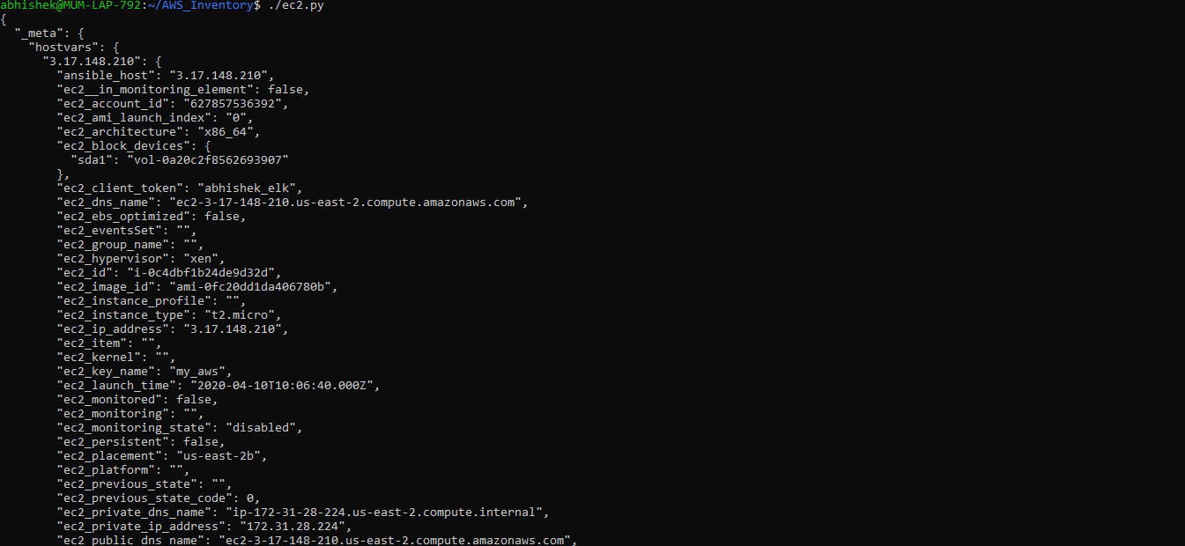

After running script ec2.py, we can ping our ec2-instance through Ansible.

Ping ec2 instance using dynamic inventory:

*ansible -m ping tag_name_abhishek_test_aws -u ubuntu*

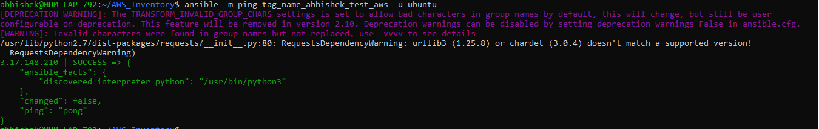

**ElasticSearch using Ansible playbook:**

* 1. Please have a look at attached ansible scrips Installation.yml

In this playbook, download task and elastic source to source.list.d

directory task are created.

* 1. Installation of **java, elasticsearch** task are scripted.
  2. Configuration of elasticsearch and jvm option are set.

Jvm option are set becasue current ec2 instance has only 0.5 GB RAM.

* 1. Started elasticsearch service to reflect all the changes.

*curl -XGET 'localhost:9200/?pretty'*

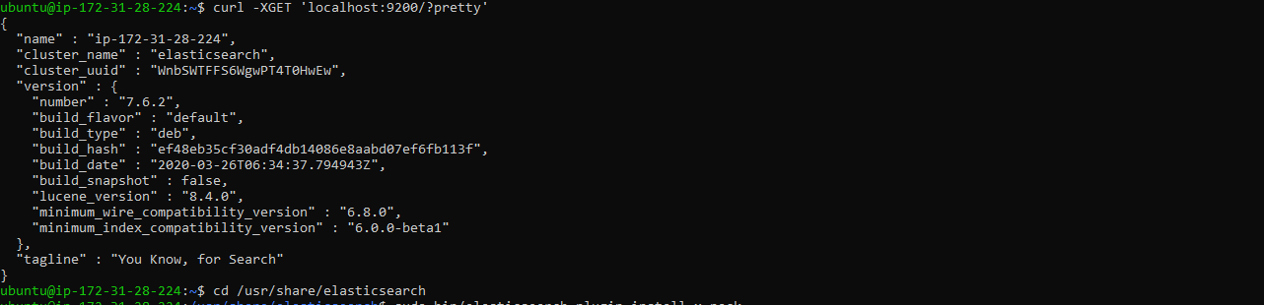

* 1. Installs Elastic Search configured in a way that requires credentials and provides encrypted communication. X-Pack is an Elastic Stack plug-in that provides many add on features such as security, alerting, monitoring, reporting, and graph capabilities.
  2. just need to add only **xpack.security.enabled: true** into

*/etc/elasticsearch/elasticsearch.yml*

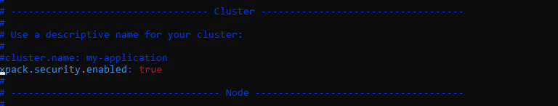

7 . After Restarting The elasticsearch service, got the authentication error.

*curl -XGET 'localhost:9200/?pretty'*

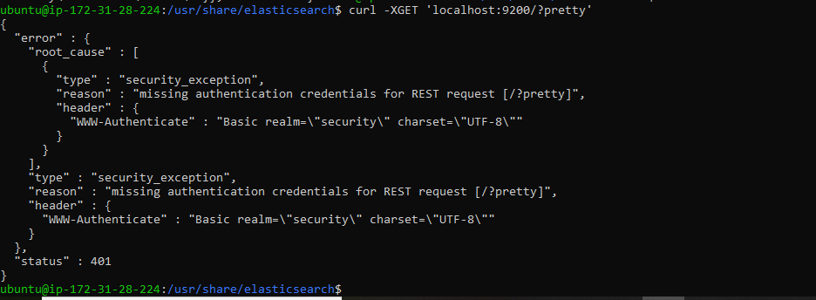

* 1. Elastic Search has default username is elastic and password is changeme.
  2. So in the script, I have configured to replace password.

After replacing password restarted elastic search service.

Note:

In the current version of elastic search x-pack is installed by default.